Is Jamaica Better Than the UK? A Deep Dive Into Two Distinct Worlds
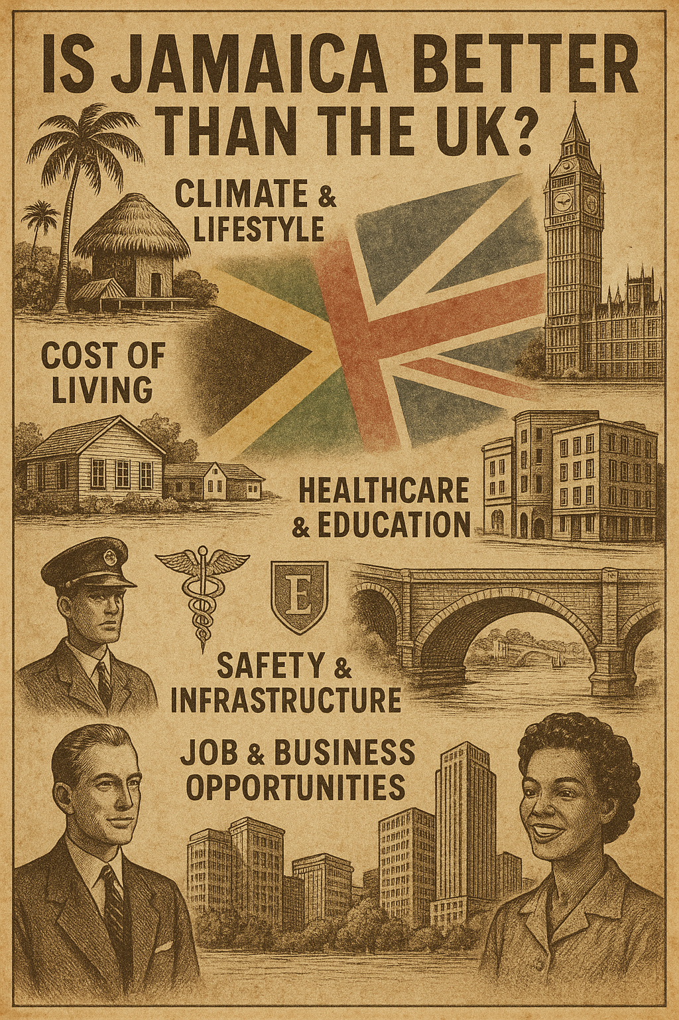
For many people, the question of whether Jamaica is better than the United Kingdom may seem too broad—or even unfair. After all, each place boasts a unique culture, climate, economy, and set of values. But for those considering relocation, investment, or even just a change of lifestyle, it is a question worth unpacking. This blog post explores Jamaica and the UK across six key dimensions: climate and lifestyle, cost of living, healthcare and education, safety and infrastructure, job and business opportunities, and cultural identity. We'll also close with some food-for-thought insights from Dean Jones, Realtor Associate and Founder of Jamaica Homes, for anyone looking to invest in Jamaica's bright and promising future.

Climate & Lifestyle
Jamaica is synonymous with sun, sea, and serenity. With year-round warm weather and a relaxed rhythm of life, the island's climate naturally encourages outdoor living, social connection, and a laid-back approach to the everyday. For those tired of grey skies and long winters, Jamaica offers a rejuvenating contrast.
In the UK, the climate is temperate but unpredictable. Summers can be charming, but winters are long, cold, and often bleak. The fast-paced urban lifestyle of London and other cities offers cultural and professional stimulation, but it can also lead to burnout and disconnection.
Verdict: If sunshine, nature, and a slower pace of life appeal to you, Jamaica may already have your heart.

Cost of Living
On paper, Jamaica's cost of living appears lower. Housing, local produce, and domestic services are more affordable compared to the UK. However, Jamaica relies heavily on imports, which makes certain goods—especially electronics, branded products, and vehicles—considerably more expensive.
In the UK, while the cost of living is higher overall, wages and services tend to reflect this. Public amenities such as transportation and healthcare are subsidized, and salaries often support the higher costs.
Verdict: For retirees, digital nomads, or entrepreneurs working remotely, Jamaica can offer tremendous value. For wage earners in traditional sectors, the UK might provide greater financial stability.

Healthcare & Education
Jamaica has both public and private healthcare, but public facilities are often overburdened and under-resourced. That said, private care on the island has made significant improvements and is generally affordable compared to international standards.
Education in Jamaica has improved, particularly in private institutions, but access and quality can vary greatly depending on region and income.
The UK enjoys the benefits of the NHS—free healthcare at the point of use. While not perfect, it is a safety net that few countries can match. UK universities and schools, especially in urban centers, are among the best in the world.
Verdict: The UK wins in terms of public healthcare and globally recognized education systems. Jamaica is catching up, particularly in private care and international schooling, making it viable for those who can afford higher-tier services.

Safety & Infrastructure
Safety is a nuanced issue in Jamaica. Crime rates can be high in certain areas, but many communities, especially gated or tourist-centric ones, are quite safe. Infrastructure varies widely. Some areas have excellent roads and internet access, while others lag behind.
The UK benefits from consistent infrastructure, efficient public transportation, and a generally low crime rate. Governance, law enforcement, and public utilities are reliable and accessible.
Verdict: The UK offers a more consistent experience in terms of safety and infrastructure, though Jamaica is rapidly improving, especially in areas experiencing real estate development and tourism growth.

Job & Business Opportunities
Jamaica presents immense opportunities for entrepreneurs and investors, particularly in tourism, real estate, agriculture, and creative industries. The business environment still has bureaucratic hurdles, but the government's push for digital transformation and foreign direct investment is paving the way for smoother operations.
In the UK, opportunities abound across finance, technology, healthcare, and education. However, the market is highly competitive and often saturated. Starting a business can be relatively straightforward, but scaling and sustaining it can be challenging.
Verdict: Jamaica is ideal for those who want to innovate and build something new with long-term vision. The UK is better for those seeking traditional corporate pathways or highly specialized careers.

Culture & Identity
Jamaica's culture is one of its strongest assets. From reggae music and Rastafarian philosophy to jerk cuisine and Olympic excellence, Jamaica punches far above its weight globally. The sense of community, national pride, and spiritual resilience are palpable.
The UK is diverse and historically rich. As a former empire and current global player, it offers exposure to almost every culture on Earth. Yet, the experience of identity in the UK can be more individualistic and less communal.
Verdict: This is highly subjective. If you value close-knit communities, expressive culture, and a strong connection to heritage, Jamaica resonates. If you prefer diversity, anonymity, and the freedom to reinvent yourself, the UK is the place.

Food for Thought: Quotes by Dean Jones
"Jamaica isn’t just a destination—it’s a decision. One that rewards the brave, the visionary, and the heart-led investor."
"The real estate market in Jamaica is like reggae—rooted in tradition, but open to constant innovation. If you know how to listen, you’ll find your rhythm here."
"Don’t just buy a property; build a legacy. Jamaica gives you soil that’s rich, not just in earth, but in story and soul."
"Some people move to escape the cold. Others move to ignite their fire. Jamaica was built for the latter."

Final Thoughts and Call to Action
Jamaica and the UK are not better or worse—they are simply different worlds offering different rewards. The UK may provide structure, services, and a well-oiled system. Jamaica, on the other hand, invites you into a life rich with color, culture, and opportunity.
If you're considering buying property in Jamaica, either as an investment or for personal use, now is an excellent time. The country is undergoing a transformation fueled by tourism, international interest, and a renewed commitment to growth. And if you're already living in Jamaica and are thinking of selling your property, the demand from locals and diaspora buyers alike makes this a lucrative moment.
Dean Jones, Realtor Associate and Founder of Jamaica Homes, specializes in guiding both local sellers and international buyers through every step of the Jamaican real estate journey. His deep understanding of the market, coupled with a passion for storytelling and cultural integrity, ensures you’re not just making a transaction—you’re making history.
Ready to make your move? Whether you're looking to invest, relocate, or sell, Dean Jones is your trusted partner in unlocking Jamaica’s potential.
Contact Dean Jones at Jamaica Homes today. Your paradise has been waiting long enough.
Disclaimer: This article is for informational purposes only and does not constitute legal or financial advice. Please note: Jamaica Homes is not authorized to offer financial advice. The information provided is not financial advice and should not be relied upon for financial decisions. Consult a regulated mortgage adviser for guidance.

